Section One: Short response 40% (59 Marks)

This section has **10** questions. Answer **all** questions. Write your answers in the spaces provided.

When calculating numerical answers, show your working or reasoning clearly. Give final answers

to **three** significant figures and include appropriate units where applicable.

When estimating numerical answers, show your working or reasoning clearly. Give final answers

to a maximum of **two** significant figures and include appropriate units where applicable.

Supplementary pages for planning/continuing your answers to questions are provided at the end of this Question/Answer booklet. If you use these pages to continue an answer, indicate at the original answer where the answer is continued, i.e. give the page number.

Suggested working time: 60 minutes.

_____________________________________________________________________________

**Question 1 (5 marks)**

A hockey player attains a high metabolic rate during a game and much of the excess heat generated must be lost by sweating. During such a game, he develops excess heat at the rate of 568 joules per second. If 90.0 % of this heat must be lost by sweating, calculate the mass of sweat produced in a 25.0 minute session. Assume all of the sweat evaporates and the latent heat of vaporisation of sweat is 2.26 x 106 J kg-1.

**Question 2 (7 marks)**

A student heated a 750.0 g solid sample in an insulated container. An electric heating coil supplied heat energy at a rate of 20.0 J s-1. She measured the temperature of the substance at half-minute intervals. The data was then graphed as shown below.



(a) Which section (A-B, B-C, etc) of the graph represents: (2 marks)

(i) the solid warming up to its melting point?

(ii) the gaseous substance increasing in temperature?

(b) Which sections of the graph represent stages where: (2 marks)

(i) the average kinetic energy of the particles was increasing?

(ii) the potential energy of the particles was increasing, whilst their kinetic energies remained

constant?

(c) ESTIMATE the quantity of heat required to convert 1.0 kg of the solid, at its melting point, to a

liquid. (3 marks)

**Question 3 (7 marks)**

A fission reaction used in nuclear power plants is the splitting of uranium-233 through thermal neutron absorption. One possible fission event produces tellurium-133 and zirconium-97 as daughter isotopes.

(a) Complete the reaction by filling in how many neutrons are produced. (1 mark)

 +  →  +  + _____ + energy

Given:

Uranium-233 3.86846 × 10-25 kg

Tellurium-133 2.20632 × 10-25 kg

Zirconium-97 1.60872 × 10-25 kg

Neutron-1 1.67492 × 10-27 kg

1u = 1.66055 × 10-27 kg

(b) Determine the mass defect in atomic mass units (amu) that results from this reaction.

(4 marks)

(c) Calculate the energy produced by this reaction in MeV. (2 marks)

**Question 4 (4 marks)**

General power outlets have three points that contact the plug attached to the electrical appliance.

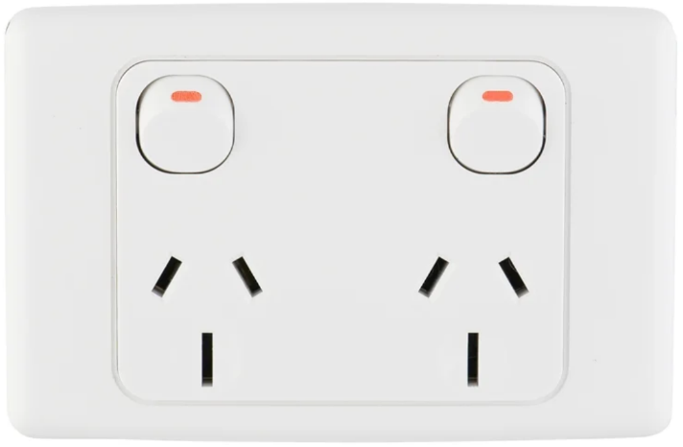

Live

Neutral

Earth

(a) State the potential difference between:

(3 marks)

Live and neutral: ________________

Neutral and Earth: _______________

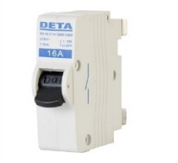Earth and Live: __________________

Fuses are being phased out of household use and being replaced by circuit breakers that perform the same function.

(b) Provide one of the benefits of a circuit breaker over a fuse. (1 mark)

**Question 5 (6 marks)**

The following diagram shows the original patent for a vacuum thermos flask.

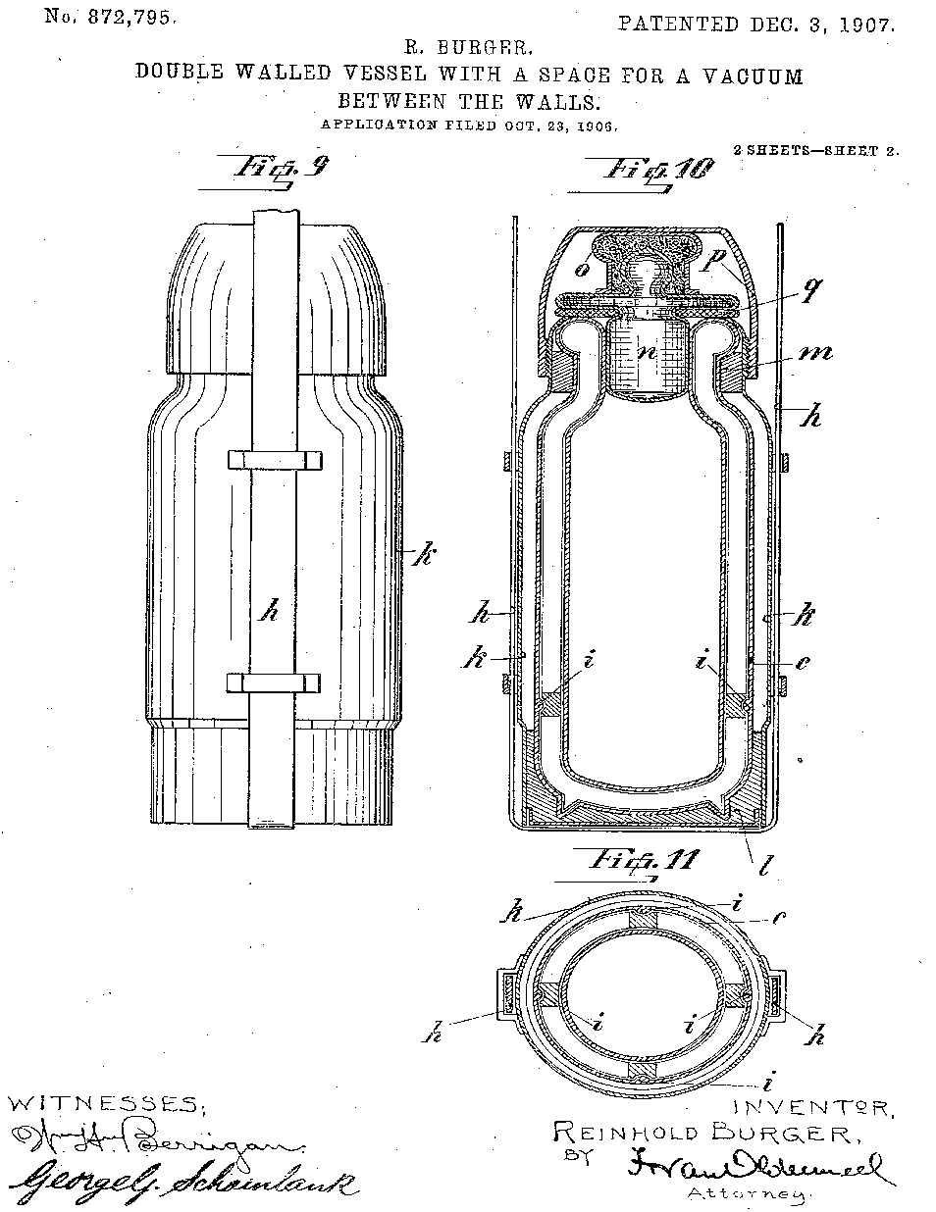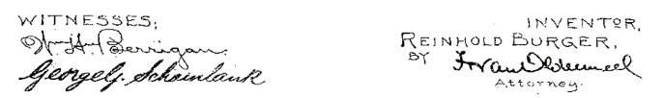

*n :plastic stopper*

*i :foam sponges*

*p : plastic cup*

*q : rubber seal*

*k : evacuated space*

*h : white walled plastic*

*c : silvered inner liner*

Explain **three** design features that reduce heat lost. Your response must include all three heat transfer processes.

**Question 6 (7 marks)**

You are provided with five resistors, each of 2.00 Ω. Show how to connect them to produce an effective resistance of 5.00 Ω, using five or fewer resistors.

(a) Draw in the space below, so that points A and B are at either end of the effective

resistance. Label the resistors in your diagram R1, R2, R3 ….etc. If you used fewer

resistors, use fewer labels. (3 marks)

**A B**

The resistor network you have drawn is now constructed and connected correctly to a 9.00V power supply.

(b) Calculate the voltage drop across each of the resistors and write the value in the table

below. If you used fewer than five resistors, leave the unused resistor box(es) blank.

(4 marks)

|  |  |
| --- | --- |
| **Resistor** | **Voltage drop (V)** |
| R1 |  |
| R2 |  |
| R3 |  |
| R4 |  |
| R5 |  |

**Question 7 (6 marks)**

The following graph shows how the temperature of 500 grams of water varies with time as it is heated with an electrical heating element.

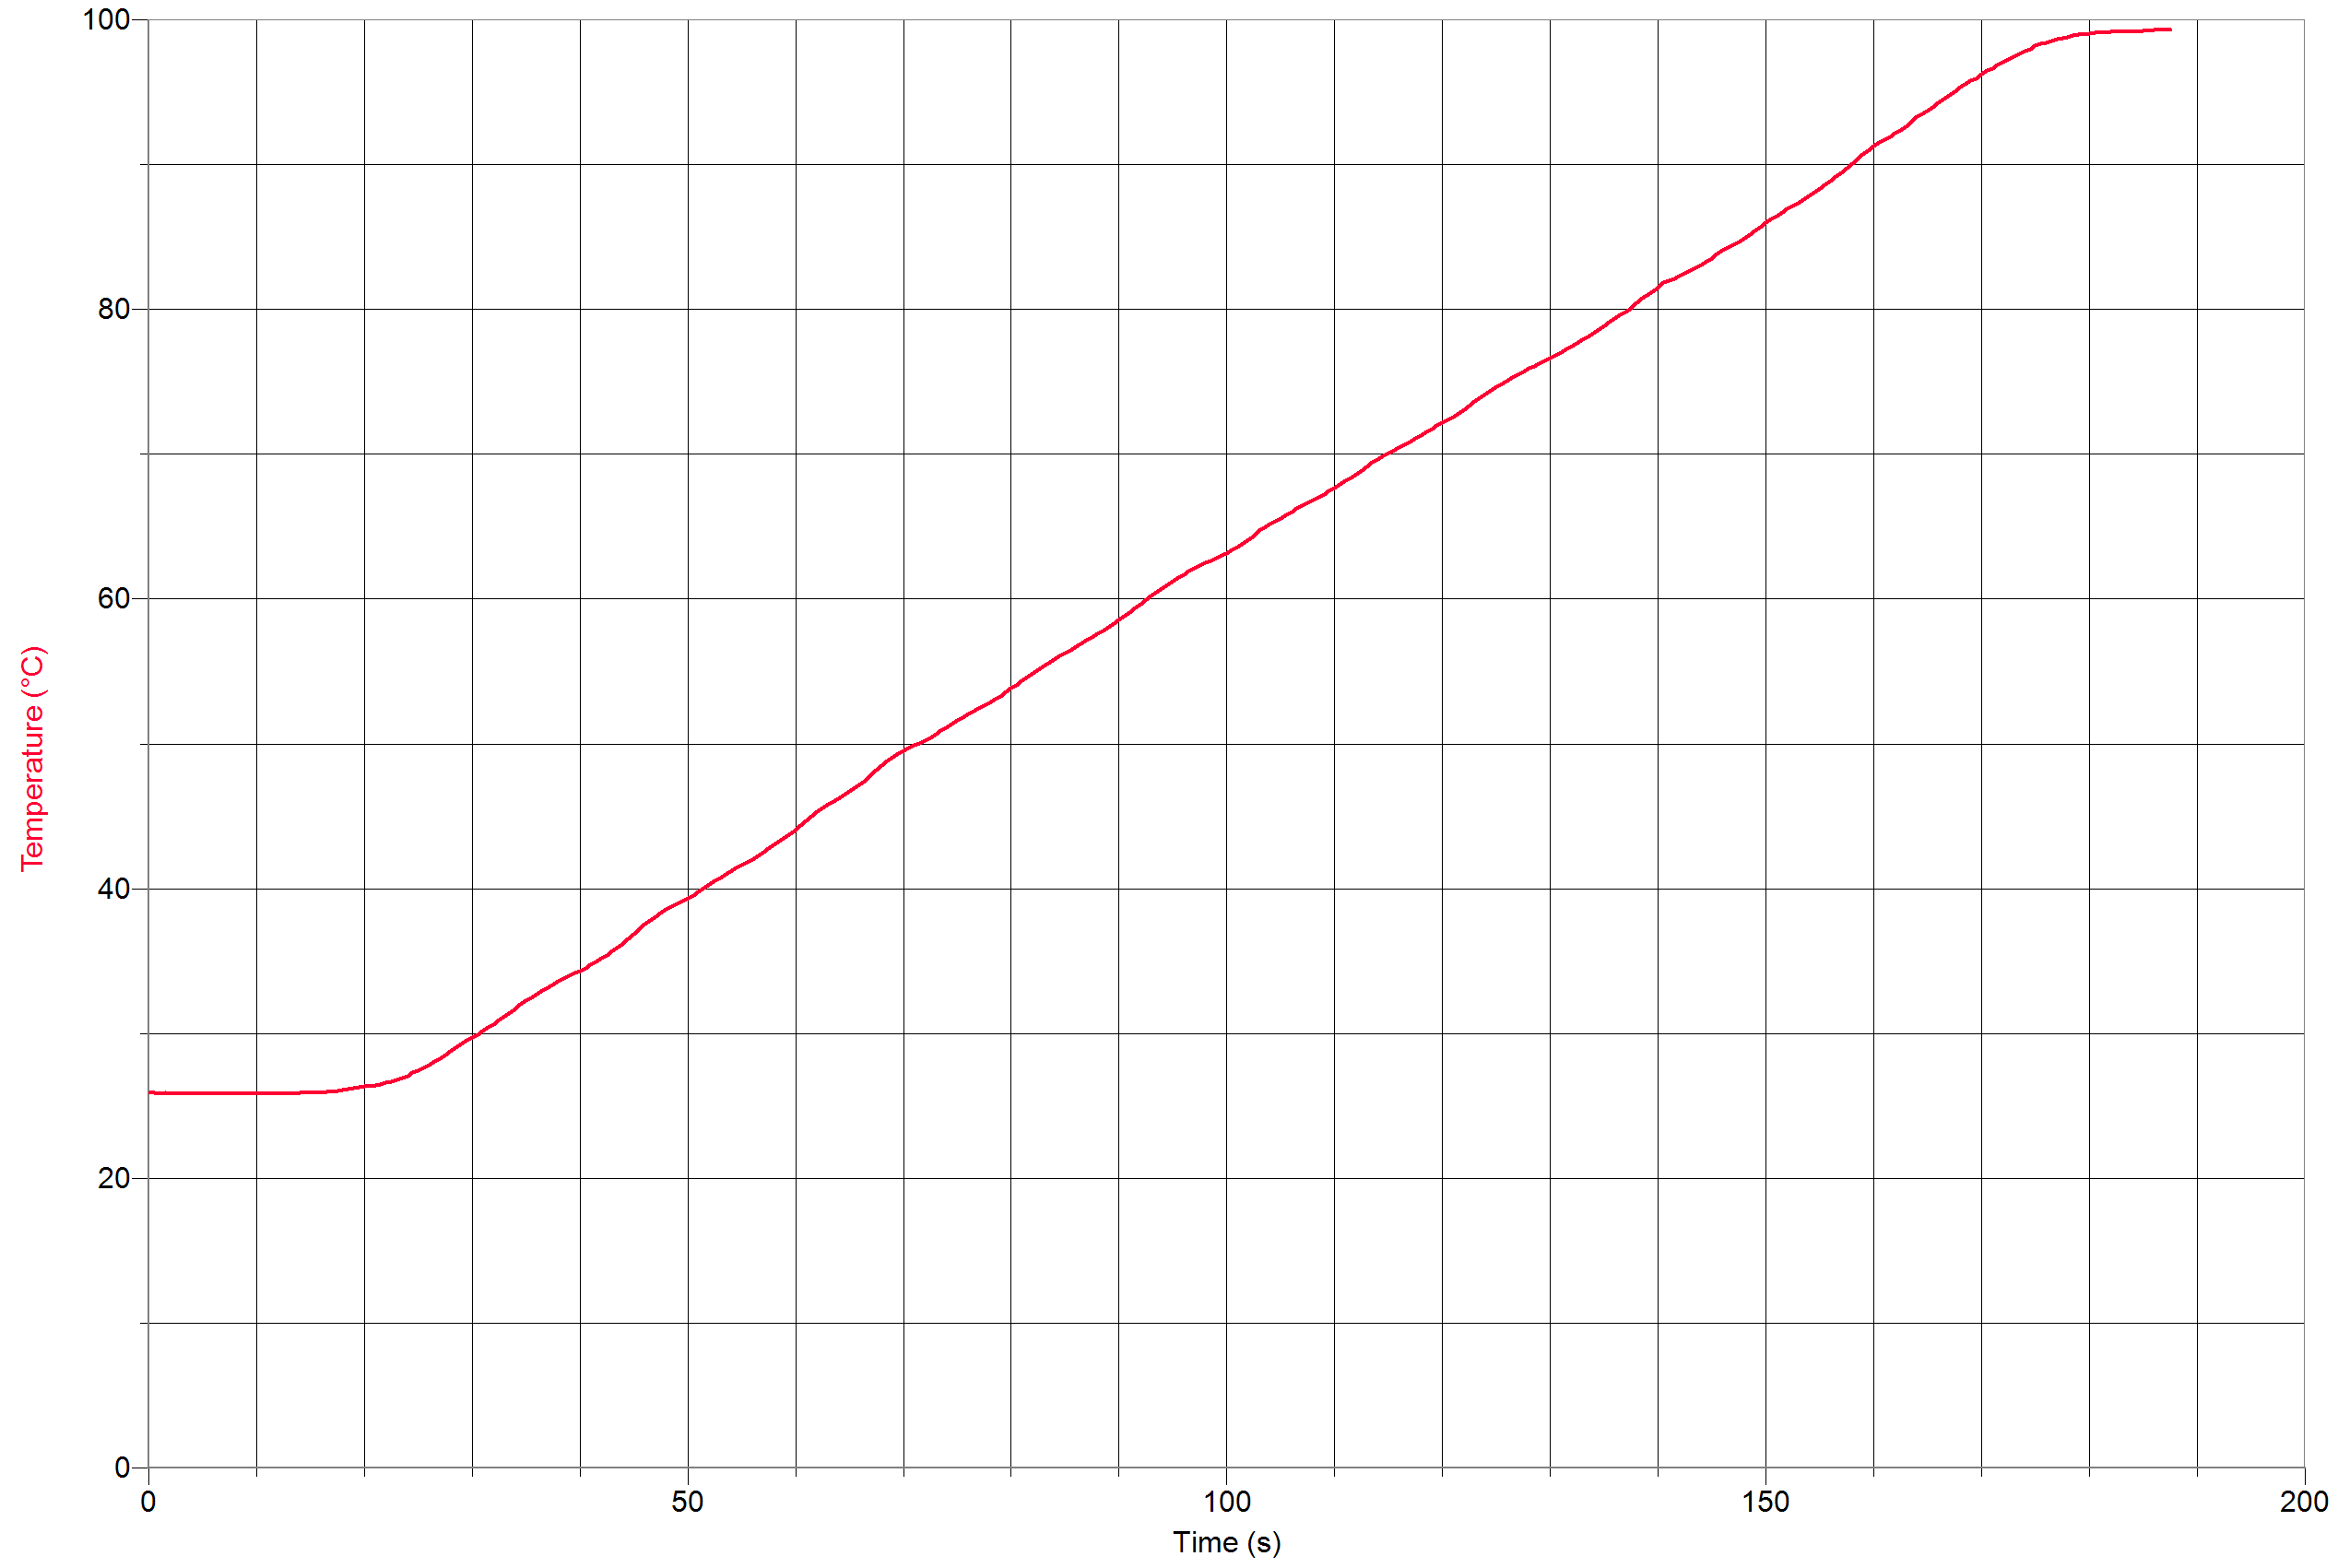

Temperature (°C)

Time (s)

(a) Calculate the gradient of the graph for the period of time where the temperature is changing. (3 marks)

**Question 7** (continued)

(b) Use the gradient to calculate the effective power of the heating element. (3 marks)

**Question 8 (5 marks)**

A 135 g block of aluminium is heated in an oven and placed into an insulated vessel containing 1.10 kg of water at 19.0 °C. The final temperature of the aluminium and water mixture was 35.0 °C when they reached thermal equilibrium. Assuming no water boils off, calculate the initial temperature of the aluminium block.

CAL = 900 J kg-1 K-1

Cwater = 4180 J kg-1 K-1

**Question 9 (8 marks)**

There are similarities and differences in the nature and properties of alpha, beta and gamma radiation.

(a) Describe what is occurring in the nucleus when a radionuclide undergoes beta + decay.

(2 marks)

(b) Provide **one** similarity and **one** difference between alpha and beta negative decay.

(2 marks)

(c) Compare the properties of alpha, beta and gamma radiation by completing the table below.

(4 marks)

|  |  |  |  |  |
| --- | --- | --- | --- | --- |
|  | **Emission speeds**  **(in terms of c)** | **Penetrating ability** | **Charge** | **Mass (kg)** |
| Alpha |  |  |  |  |
| Beta |  |  |  |  |
| Gamma |  |  |  |  |

**Question 10 (4 marks)**

Determine each of the unknown particles in the nuclear equations below. If the particle is an isotope, provide its full name.

(a) ${}_{20}^{45}{Ca → {}_{21}^{45}{Sc}}$ + _____ + ${}_{0}^{0}{\overline{υ}}$ particle: _____________________

(b) ${}_{5}^{11}{B+ {}_{2}^{4}α → {}_{7}^{14}N}$ + ______ particle: _____________________

(c) ${}_{0}^{1}{n+ {}_{92}^{235}U → {}_{38}^{140}{Sr}}$ + ______ + $2{}_{0}^{1}n$ particle: _____________________

(d) ${}_{1}^{2}{H+ {}_{1}^{3}H → {}_{0}^{1}n}$ + ______ particle: _____________________

**End of Section One**

**This page has been left blank intentionally.**

**Section Two: Problem-solving 52% (79 Marks)**

This section has **seven** questions. Answer **all** questions. Write your answers in the spaces provided.

When calculating numerical answers, show your working or reasoning clearly. Give final answers to **three** significant figures and include appropriate units where applicable.

When estimating numerical answers, show your working or reasoning clearly. Give final answers to a maximum of **two** significant figures and include appropriate units where applicable.

Supplementary pages for planning/continuing your answers to questions are provided at the end of this Question/Answer booklet. If you use these pages to continue an answer, indicate at the original answer where the answer is continued, i.e. give the page number.

Suggested working time: 80 minutes.

_____________________________________________________________________________

**Question 11 (15 marks)**

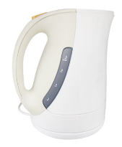The gas hot water system breaks in a person’s home and they wish to pour a hot bath. They fill a bathtub with 125 kg of water at 24.0 °C. They decide to use an electric kettle that can boil 2.00 kg of 24.0 °C water a time and pour this boiling water into the bathtub to raise its temperature. The kettle is rated at 1800 W and is supplied by 240.0 V AC power.

(a) Calculate the electrical resistance of the kettle when it is operating. (3 marks)

(b) Calculate the charge that flows through the kettle element in a time of 45.0 seconds.

(4 marks)

(c) Calculate the time taken for the kettle to bring the water to its boiling point. (3 marks)

The person decides that they only have the patience to boil 5 kettles of water before they have had enough and want to have their bath.

(d) Calculate the final temperature of the bathtub. (4 marks)

(e) State **one** valid assumption about any of the calculations you have made in this question.

(1 mark)

**Question 12 (11 marks)**

Two physics students conducted an experiment to measure the resistance of a resistor. Their results are shown in the table below.

*Table 1: Student’s results table*

|  |  |
| --- | --- |
| **Voltage (V)** | **Current (mA)** |
| 4 | 29 |
| 6 | 44 |
| 8 | 58 |
| 11 | 82 |
| 12 | 88 |

(a) Graph the students’ results on the grid below. (5 marks)

graph paper C whirlygig 8 by 10

(b) Using your graph, calculate the experimental value for the resistance for the resistor.

(3 marks)

(c) The students read the colour coding on the resistor, finding the accepted value of the resistor is 130 Ω ± 2%.

Calculate the percentage difference between the experimental value you calculated in part c) and the accepted value. Comment on whether your experimental result is within the accepted range or not.

(3 marks)

**Question 13 (9 marks)**

A family is worried that their electricity bill has risen considerably over the years and decide to modify their home and behaviour in an effort to reduce their electricity bill. They currently have 16, 18.0 W halogen globes in the ceiling which have an electrical efficiency of 36.0% and an average life span of 2,000 hours. They decide to replace all the globes with 5.00 W LEDs that have an electrical efficiency of 76.5% at a cost of $10.50 per globe. These LEDs have an average lifespan of 25,000 hours. The household determines that, in an average week, the 16 halogen globes each run for 12.0 hours.

(a) Calculate the total energy that the halogen globes would consume in one year. You do not need to consider electrical efficiency in your calculation. (2 marks)

Synergy currently charge an average of 32.0 cents per kW h.

(b) Calculate the cost of running the halogen globes in one year. (2 marks)

All of the globes are replaced with LEDs at a total cost of $168 and the family decide to make an effort to reduce the time they have the light turned on, reducing the average run time to 9.00 hours each week.

(c) Calculate the cost of running the LEDs given the information above and hence, calculate how much money they would save each year. If you could not obtain an answer to part (b), you may use $75.00. (3 marks)

(d) Calculate how long it would take before the family start to save money on their electricity

bill after the initial outlay cost of $168. (2 marks)

**Question 14 (13 marks)**

Radon-222 (half-life 3.83 days) is a naturally occurring inert gaseous isotope of radon that forms from the alpha decay of radium-226 (half-life 1.6 × 103 years). Radium-226 is found in many rocks, building materials and buildings. Because radon-222 is a gas and its decay releases tissue-damaging radiation, it can cause lung cancer when inhaled into the lungs over a prolonged period.

(a) Write the equation for the alpha decay of radium-226 to radon-222. (2 marks)

(b) Radon-222 also undergoes alpha decay. Explain why these alpha particles are so much more dangerous to humans than those released by the parent radium. (3 marks)

A sample of radon-222 was measured to have an initial activity of 1.40 kBq.

(c) Calculate the activity of the sample 2.00 weeks later. (3 marks)

Consider a sample of radon that was trapped in a closed room. A 78.0 kg person stayed in the room for eight hours. In that time their lungs, of mass 2.40 kg absorbed energy released by alpha particles equal to 0.160 J.

(d) Determine the absorbed dose this person could receive. (2 marks)

(e) Determine the maximum dose equivalent of this radiation. (2 marks)

The table below describes the approximate physiological effects of different types of dose equivalents

|  |  |
| --- | --- |
| **Whole Body Dose (mSv)** | **Effect** |
| 0 – 100 | No observable effect |
| 100 – 1000 | Slight to moderate decrease in white blood cell counts |
| 350 - 500 | Temporary Sterility women; men |
| 1000- 2000 | Significant reduction in blood cell counts, brief nausea and vomiting. Rarely fatal. |
| 2000 – 5000 | Radiation sickness - Nausea, vomiting, diarrhoea, hair loss, skin rashes, severe blood damage, bone marrow damaged, hemorrhage, fatalities. |
| **Localised Dose** | **Effect** |
| 0 – 100 | No observable effect |
| 100 – 300 | Decrease in red blood cell count. Inflammation of tissue |
| 300 - 800 | Damage to capillaries and smaller blood vessels. |
| 1000- 2000 | Significant hemorrhaging of large blood vessels. Significant tissue atrophy |
| 2000 – 5000 | Severe damage to tissues, major hemorrhaging, organ and tissue failure. |

Table 1: Physiological Effects of Radiation on an Adult Human

(f) State the physiological effects that the person might receive after being in this room for

8 hours. (1 marks)

**Question 15 (16 marks)**

Consider the following complex circuit diagram below:

5.00 Ω

2.00 Ω

8.00 Ω

1.00 Ω

3.00 Ω

12.0 V

4.00 Ω

(a) Show that that the total resistance of the circuit is 9.83 Ω. (5 marks)

(b) Calculate the voltage drop across the 2.00 Ω resistor. (4 marks)

(c) Calculate the current that flows through the 8.00 Ω resistor. (4 marks)

(d) Explain what would happen to the power drawn by the circuit if the 3.00 Ω resistor was

removed from the circuit. (3 marks)

**Question 16 (8 marks)**

The data sheet for the radioisotope lead-210 is shown below:

|  |
| --- |
| RADIONUCLIDE SAFETY DATA SHEET  NUCLIDE: Pb-210/Bi-210/Po210 FORMS: SOLUBLE |
| PHYSICAL CHARACTERISTICS:  HALF-LIFE: 20.4 years TYPE DECAY: beta -, beta -, alpha  (Pb, Bi and Po, respectively.)  Energies: beta - (Pb) 0.061 MeV, beta - (Bi) 1.16 MeV, alpha (Po) 5.35 MeV  Hazard category: C - level (low hazard): .0001mCi to 0.1 mCi  B - level (Moderate hazard): > 0.01 mCi to 1.0 mCi  A - level (High hazard): greater than 1.0 mCi  EXTERNAL RADIATION HAZARDS AND SHIELDING:  The external exposure hazard is from the Bi-210 beta particle (99%) with maximum energy of 1.16 MeV. The maximum range of these betas in various materials is as follows: Air ~100 inches, Water ~0.17 inches, Glass ~0.07 inches. The beta dose rate at 1 cm from 1 mCi (from the Bi-210 in equilibrium) is approximately 310,000 mrad/hr.  HAZARDS IF INTERNALLY DEPOSITED:  This is a highly radiotoxic material. The principal hazard from Pb-210 occurs if the material is allowed into one's body. The Campus Annual Limit of Intake (oral), based upon 10% of the dose limit to bone surfaces, is 0.054 uCi. The effective half-life in the body is 1200 days. The campus ALI for inhalation is 0.0025 microcuries also based upon dose to bone surfaces. |

(a) Write the **three** separate nuclear equations for the decays of lead-210, bismuth-210 and polonium-210. (3 marks)

A curie (Ci) is another unit of radioactivity. Originally it was defined as the activity of 1 gram of radium-226. 1 Ci = 3.70 ×1010 Bq = 37.0 GBq.

(b) Calculate the activity range, in Bq, of hazard category C (low hazard) (3 marks)

(c) Explain why the external exposure hazard is from bismuth-210 and not the other two radioisotopes. (2 marks)

**Question 17 (7 marks)**

A thermistor is a device in which resistance varies with temperature. The characteristics of a particular thermistor are shown in the diagram.

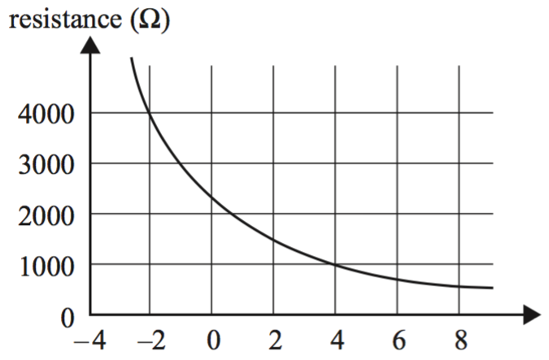

Temperature (°C)

Resistance (Ω)

2000

1500

1000

500

0

(a) Calculate the current in mA that would flow through the thermistor at 4.00 °C if the voltage across it were 2.50 V. Express your answer to 3 significant figures. (3 marks)

This thermistor is now used to control the temperature of a freezer unit of a refrigerator. The circuit is shown below. The switch controlling the freezer switches it on when the voltage across the variable resistor R is equal to (or greater than) 2.00 V. The freezer unit must turn on when the temperature is -2.00 °C or higher.

6.00 V

Variable to relay controlling

resistor R freezer

thermistor

(b) Calculate the total current in mA required to flow through the circuit when the temperature is

-2.00 °C in order to meet the required voltage across the resistor. (4 marks)

**End of Section Two**

**Section Three: Comprehension 8% (12 Marks)**

This section has **one** question. Write your answers in the spaces provided.

When calculating numerical answers, show your working or reasoning clearly. Give final answers to **three** significant figures and include appropriate units where applicable.

When estimating numerical answers, show your working or reasoning clearly. Give final answers to a maximum of **two** significant figures and include appropriate units where applicable.

Supplementary pages for planning/continuing your answers to questions are provided at the end of this Question/Answer booklet. If you use these pages to continue an answer, indicate at the original answer where the answer is continued, i.e. give the page number.

Suggested working time: 10 minutes.

**Question 18 (12 marks)**

**How does reverse cycle air conditioning work?**

Reverse Cycle Air Conditioning (RCAC) is a style of air conditioning that performs both heating and cooling functions. Unlike other air conditioning systems, this reverse cycle method allows the user to either cool down a house in the summer or warm it up in the winter using a single device. This method of air conditioning is a blessing in countries that have very different seasons. This is because you don’t need to invest in two different devices for solving the heating/cooling problem of your house.

A device commonly known as “Heat Pump” is the one that performs RCAC and it was designed to work under the “Heat Exchange” principle. In this way, the heat pump absorbs the heat from the outside air even in cold winter nights and transfers it inside. Therefore, reverse cycle air conditioners differs from other similar systems because they use a fluid (refrigerant gas) for the heat exchange whereas others create heat by using electricity.

**But what is a Heat Pump?**

A Heat Pump is a device that has the capability to use the refrigeration cycle to cool down an internal environment and ***reverse*** this cycle to warm it up. This device transfers heat by circulating a chemical substance called “Refrigerant”. This refrigerant is a fluid that easily transfers heat during a change of physical state – from gas to liquid and back again.

This means that, if the refrigerant is moved around using a pump and its physical state is changed, then heat energy will be absorbed or removed, allowing heat to be transferred from one place to another.

For this reason, a Heat Pump has four main parts:

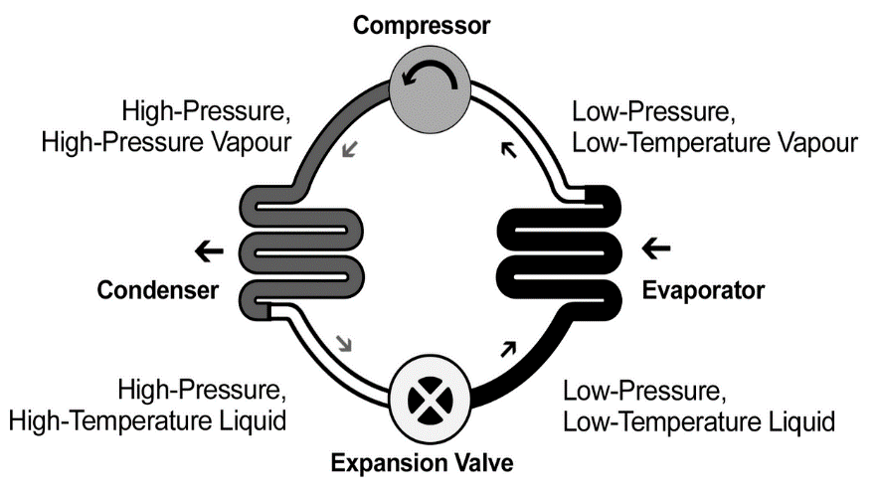

**Compressor:** Pump for *moving* around the refrigerant.

**Condenser:** Coil that *turns* the refrigerant from *Gas* into *Liquid.*

**Restriction Device:** Device that *turns* *Liquid* into a *Liquid Vapor Mixture.*

**Evaporator:** Coil that *turns* the Refrigerant from *Liquid* into *Gas.*

Figure 1: Basic Heat Pump

(a) In the boxes in Figure 1 above, write the correct letter from the options below. (2 marks)

A. Heat removed from refrigerant B. Heat absorbed by refrigerant.

causing refrigerant to condense causing refrigerant to evaporate

C. Heat removed from refrigerant D. Heat absorbed by refrigerant.

causing refrigerant to evaporate causing refrigerant to condense.

Heat pumps also have a reversing valve which is the magical mechanical device that allows RCAC systems to perform both heating and cooling functions. It is this, because the reversing

valve changes the direction of the flow of refrigerant, which changes the direction of heat transfer. As a consequence, the heat pump uses a fan to move warm air and capture its heat through the refrigerant and then move it from inside to outside your house allowing you to have cool air. Then, if you need to heat up your house, the reversing valve will change the direction of the heat transfer, so the heat from the outside air will be transferred inside the house. This process will repeat over and over again allowing you to maintain a comfortable temperature.

Figure 2: Heating cycle Figure 3: Cooling cycle.

Figure 2 shows the heating cycle with the reversing valve changing the direction of the heat

pump. With the heat pump reversed, the properties and actions at various parts of the cycle have

been changed.

(b) In the space below, complete the annotations that would be at parts A, B and C in the diagram. Use Figure 3 to assist you. (3 marks)

|  |  |
| --- | --- |
| **A** |  |
| **B** |  |
| **C** |  |

RCAC systems can make the somewhat impossible claim of their heating cycle being up to 600% power efficient, which means that it can take one unit of electrical energy and turn it into 6 times as much heating. Under mild conditions, some products can achieve power efficiencies of over 1000%. RCAC technology allows the system to extract heat found in ambient air and move it either inside your home, to keep it warm in winter, or outside to keep your home cool in summer. Because moving ambient heat doesn’t require a lot of energy, reverse cycle air conditioners use a lot less energy to heat your home. By comparison, electric or gas heaters use a lot more energy because they need to produce heat directly via an electric element or gas burner, instead of simply moving it from one place to another.

Consider an RCAC system that operates on 240 V AC power and draws a current of 11.0 amps when it is running. The system claims:

“Cooling output = 7.10 kW Heating output = 8.00 kW”

(c) Calculate the electrical power drawn by the RCAC system. (2 marks)

(d) Explain, making reference to the final paragraph of the passage, why this input energy (which is less than 8.00 kW for heating) is not violating the law of conservation of energy. (3 marks)

(e) If an electrical heater was installed and used the same electrical energy as the RCAC system, calculate how the power efficiency of the RCAC system. (2 marks)

**End of questions**